**Property Decorators – getters, setters and deleters**

The following snippet works as expected:

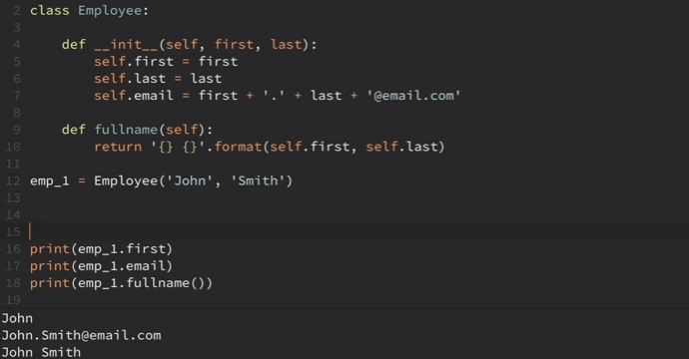

But when we set the first name to something different we encounter a problem:

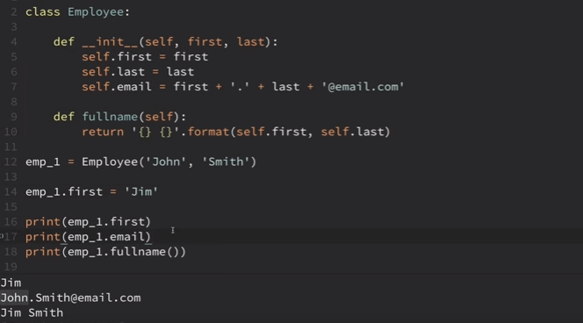

The email does not return the expected result. The fullname() method however grabs the current first and last name.

One way to solve this is to create a new method explicitly to create email. 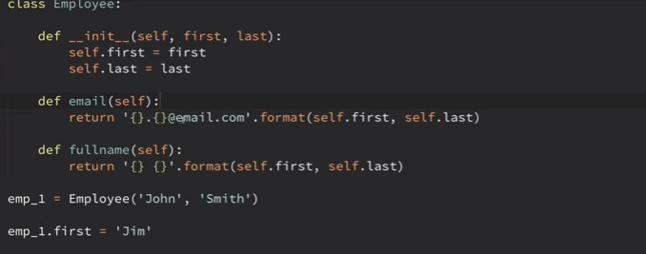

But it is not helpful on large scale, since everyone else using this code would have to change it as well.

***‘getters’***

So we can create a property decorator that defines a method that we can access it as an attribute. The following is the change:

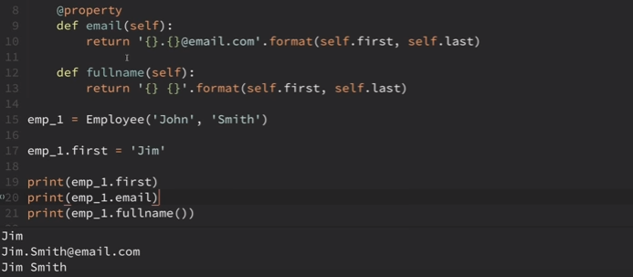

So we are defining a method in a class but accessing it like an attribute

The same can be done for fullname as well:

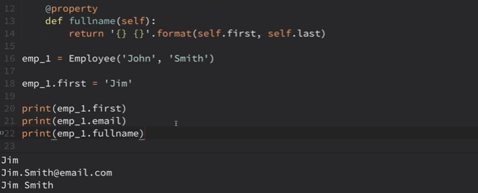

The above examples were ‘getters’.

***‘setters’***

Now we will see some ‘setters’.

The following snippet we are trying to set the first and last name by feeding in the fullname. The following code is added to existing code:



***‘deleters’***

This is used to delete an instance of the class.

